TERRACE COVERING WITH ROTATABLE ALUMINIUM BLADES

Manufacturer
RENSON Sunprotection-Screens NV, Kalkhoevestraat 45, 8790 Waregem – Belgium
Tel. +32(0)56 62 71 11, fax. +32 (0)56 60 28 51, info@renson.be, www.renson-outdoor.com

(You can omit the text highlighted in red according to your choice)

Description
Algarve® is an aluminium terrace covering, which can be free-standing or mounted onto a façade, and is supported by vertical columns. This terrace covering, which allows adjustable sun protection fabric or ventilation, can be operated electronically.

Dimensions
Span: Minimum 1800 mm
Maximum 4500 mm
Pivot: Minimum 2610 mm
Maximum 6050 mm
Free passage height: Dependent on the supporting structure
Total height, without the motor box: Fee passage height + 230 mm
Total height including the motor box: Free passage height + 360 mm
Coupled:
Two roof sections coupled on the pivot side to achieve a longer span side.
No extra column is required between each roof section.
Span per roof section: Minimum 1500 mm
Maximum 4500 mm
Span (the sum of the 2 roof sections) Minimum 3000 mm
Maximum 6000 mm
Information:
The "Span side" corresponds to the span of the blades
The "Pivot side" is the side where the blades rotate (or pivot)

System implementation

Installation type:
- Installation type 1:
  - Free-standing, 4 columns
  - Self-supporting structure
- Installation type 2:
  - Façade mounting
  - Building situation 1:
    - Installed with one side against a backing, supporting construction/structure
    - Blades parallel to the wall
    - Two columns
  - Building situation 2:
    - Installed with one side against a backing, supporting construction/structure
    - Blades perpendicular to the wall
    - Two columns
  - Building situation 3:
    - Installed with two sides (pivot and span-side) against a backing, supporting construction/structure
    - One column

Columns:
- Installation requires 1, 2 or 4 columns, depending on the installation type.
- They are made of square aluminium box profile, 110 mm x 110 mm.

Mounting bases:
There are 2 types:
- Visible mounting bases with a visible ground plate
- Invisible mounting foot

Frame:
- A sturdy surrounding frame made of extruded aluminium profiles
- Height: 230 mm
- Inclination: 0°

Blades:
- Sun protection blades made of extruded aluminium
- Rotatable through 150°
- Underside: completely flat
- Upper side: sharply defined edges + water drainage gutter
- Side edges equipped with hidden fixed L-profile to stop water run-back
- The specific design ensures water drainage when the blades are closed
- And water drains off when you rotate the blades after a shower
- Blade mounting:
  - Fitting into the pivot-sides using the stainless steel shafts
  - A slight inclination on the blades for optimum water drainage

Motorisation:
- Linear motor with a driving profile and RTS control
- Placement:
  - The motor is fitted in the frame
  - The motor is concealed in an aluminium housing.
    - 130 mm in height
    - 580 mm long
    - Painted in the same RAL colour as the structure

Water drainage:
- Through the column: A Ø 50 mm hole is provided for water drainage in the gutter on the edge of each pivot -side. Each hole has a drainage trap that serves as leaf catcher and a connection for a drainpipe (Ø 50 mm) An opening is provided at the bottom of the column to discharge rainwater. A Ø 50 mm drain pipe connects to the discharge trap to channel the water out of the column.

Colour:
All visible aluminium profiles are coated in your choice of architectural textured RAL colour (60-80 microns)

Assembly:
All fixings (e.g. screws) are made of stainless steel

Power supply and wiring:
Electrical cables are fully integrated, invisibly, into the terrace covering

Technical data:

Maximum weight of snow load:
Dependent on the dimensions
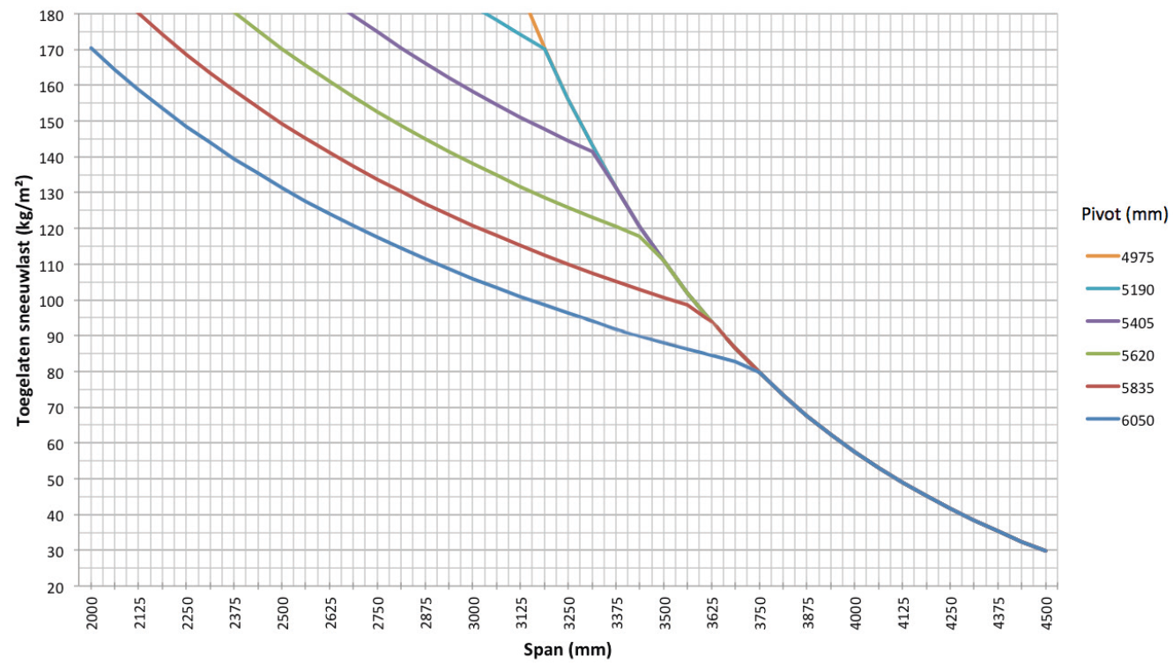

Maximum wind speed when controlling the blades:
50 km per hour

Wind resistant up to:
120 km per hour (with closed blades)

Water drainage and precipitation rate:
The terrace covering can handle precipitation rate that corresponds to a rain shower with an intensity of 0.04 L/sec/m² up to 0.05 L/sec/m², which a maximum duration of 7 minutes. This type of heavy shower occurs on average twice a year. (See the Belgian rain statistics: NBN B 52-011)

Warranty
- Five years product warranty on the structure (covering all faults that could occur during normal domestic use and with regular maintenance)
- Five years warranty on Somfy® automation
- Two years warranty on the blade motor
- Ten years warranty on the colour integrity of powder coating on the aluminium profiles
- Five years warranty on gloss (powder coating)

Options

LED blade lighting
- Blades can be equipped with integrated LED lighting. 180 LEDs/m
  - Warm white light (+/- 2800 K, 1700 lumens/ m)
  - Pure white light (+/- 5000 K, 1700 lumens/ m)
- Connection: 230 Volts AC
- This lighting is controlled, as standard, by an independent remote control (on/off and dimming). Control with a Somfy® RTS is possible at extra cost.

Up/Down LED ventilator:
Integrated LED lighting along the full length of the inner side of the frame equipped with Upwards and/or Downwards lighting
- Up:
  - Warm white light, 120 LEDs/M | +/- 2800 K | 550-680 lumens/m
  - Pure white light, 120 LEDs/M | +/- 5000 K | 550-680 lumens/m
- Down:
  - Warm white light, 120 LEDs/M | +/- 2800 K | 550-680 lumens/m
  - Pure white light, 120 LEDs/M | +/- 5000 K | 550-680 lumens/m
  - RGB 60 LEDs/m | 550-700 lumens/m

Glass blade
A translucent blade, comprising 8 mm, mat painted safety glass and an aluminium supporting profile
Maximum 5 glass blades on a single roof installation
Max. Three glass blades on a coupled roof installation

Beam:
- You can equip the terrace covering with a Beam-
module, an aluminium housing that can house a heating element (Heat) and loudspeakers (Sound).
- Mountable on the inner side of the frame profile on the Span-side
- You can swing the module (stepless) through 30° for adjustment bolt

Heat:
- A heating power element that you can integrate in the Beam-module
- The visible, corrugated plate is anodised in black
- Convection heat
- Power: 2600 W/Heat, Power rating = 12 A/Heat
- IP 65
- RTS control (exclusive receiver, remote and controls)

Sound:
- "Flat Panel" type speakers that integrate into the Beam-module
- "Plane Wave" technology
- 25 W RMS, Flat Panel Speaker
- 50 W RMS, Flat Panel Speaker
- IP 65
- Connection: Connects to a tuner/amplifier using an audio cable

Rain sensor kit:
- Capacity: Rain sensor, fixing materials and accessories
- Action:
  - Closes the blades automatically when there is rain
  - Rotates the blades to their pre-set snow position whenever there is precipitation combined with a freezing temperature
- It is mounted on a slight incline and has a tiny heating power element for better sensor drying

Wind sensor kit:
- Capacity: Somfy Eolis RTS Wind sensor and extra accessories
- Action: The blades should be closed when wind speeds are > 50 km/hour, to conform to our warranty terms
- The wind sensor has priority over the rain sensor

Norms
This product is made to conform to, satisfies and/or has been tested according to the norm: EN 13561

